Regional Information Report 2AYY-XX

Assessment of spot shrimp *Pandalus platyceros* abundance in Prince William Sound, 1992–2016

by

Joshua Mumm

Kenneth J. Goldman and

Janet Rumble 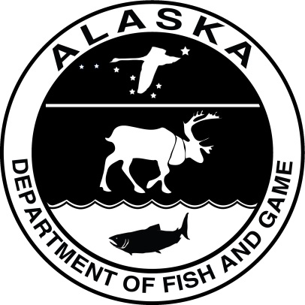

Month 2017

Alaska Department of Fish and Game Division of Commercial Fisheries

Symbols and Abbreviations

The following symbols and abbreviations, and others approved for the Système International d'Unités (SI), are used without definition in the following reports by the Divisions of Sport Fish and of Commercial Fisheries: Fishery Manuscripts, Fishery Data Series Reports, Fishery Management Reports, and Special Publications. All others, including deviations from definitions listed below, are noted in the text at first mention, as well as in the titles or footnotes of tables, and in figure or figure captions.

**Weights and measures (metric)**

centimeter cm

deciliter dL

gram g

hectare ha

kilogram kg

kilometer km

liter L

meter m

milliliter mL

millimeter mm

**Weights and measures (English)**

cubic feet per second ft3/s

foot ft

gallon gal

inch in

mile mi

nautical mile nmi

ounce oz

pound lb

quart qt

yard yd

**Time and temperature**

day d

degrees Celsius °C

degrees Fahrenheit °F

degrees kelvin K

hour h

minute min

second s

**Physics and chemistry**

all atomic symbols

alternating current AC

ampere A

calorie cal

direct current DC

hertz Hz

horsepower hp

hydrogen ion activity pH

(negative log of)

parts per million ppm

parts per thousand ppt,

‰

volts V

watts W

**General**

Alaska Administrative

Code AAC

all commonly accepted

abbreviations e.g., Mr., Mrs., AM, PM, etc.

all commonly accepted

professional titles e.g., Dr., Ph.D.,

R.N., etc.

at @

compass directions:

east E

north N

south S

west W

copyright ©

corporate suffixes:

Company Co.

Corporation Corp.

Incorporated Inc.

Limited Ltd.

District of Columbia D.C.

et alii (and others) et al.

et cetera (and so forth) etc.

exempli gratia

(for example) e.g.

Federal Information

Code FIC

id est (that is) i.e.

latitude or longitude lat or long

monetary symbols

(U.S.) $, ¢

months (tables and

figures): first three

letters Jan,...,Dec

registered trademark ®

trademark ™

United States

(adjective) U.S.

United States of

America (noun) USA

U.S.C. United States Code

U.S. state use two-letter abbreviations (e.g., AK, WA)

**Mathematics, statistics**

*all standard mathematical*

*signs, symbols and*

*abbreviations*

alternate hypothesis HA

base of natural logarithm *e*

catch per unit effort CPUE

coefficient of variation CV

common test statistics (F, t, χ2, etc.)

confidence interval CI

correlation coefficient

(multiple) R

correlation coefficient

(simple) r

covariance cov

degree (angular ) °

degrees of freedom df

expected value *E*

greater than >

greater than or equal to ≥

harvest per unit effort HPUE

less than <

less than or equal to ≤

logarithm (natural) ln

logarithm (base 10) log

logarithm (specify base) log2, etc.

minute (angular) '

not significant NS

null hypothesis HO

percent %

probability P

probability of a type I error

(rejection of the null

hypothesis when true) α

probability of a type II error

(acceptance of the null

hypothesis when false) β

second (angular) "

standard deviation SD

standard error SE

variance

population Var

sample var

Regional Information Report 2AYY-XX

Assessment of spot shrimp *Pandalus platyceros* abundance in Prince William Sound, 1992–2016

by

Joshua Mumm, Kenneth J. Goldman, and Janet Rumble

Alaska Department of Fish and Game, Division of Commercial Fisheries, Homer

Alaska Department of Fish and Game  
Division of Commercial Fisheries  
333 Raspberry Road, Anchorage, Alaska, 99518-1565

Month Year

The Regional Information Report Series was established in 1987 and was redefined in 2007 to meet the Division of Commercial Fisheries regional need for publishing and archiving information such as area management plans, budgetary information, staff comments and opinions to Alaska Board of Fisheries proposals, interim or preliminary data and grant agency reports, special meeting or minor workshop results and other regional information not generally reported elsewhere. Reports in this series may contain raw data and preliminary results. Reports in this series receive varying degrees of regional, biometric and editorial review; information in this series may be subsequently finalized and published in a different department reporting series or in the formal literature. Please contact the author or the Division of Commercial Fisheries if in doubt of the level of review or preliminary nature of the data reported. Regional Information Reports are available through the Alaska State Library and on the Internet at: <http://www.adfg.alaska.gov/sf/publications/>.

Author Name,

Alaska Department of Fish and Game, Division of Commercial Fisheries,

Address, USA

and

Coauthor

Alaska Department of Fish and Game, Division of Commercial Fisheries,

If from a different office then Address, USA

This document should be cited as follows:

Author last name, initials, and coauthor initials then last name. Year. Report title. Alaska Department of Fish and Game, Division of Commercial Fisheries, Regional Information Report 2A.Year-XX, Anchorage.

The Alaska Department of Fish and Game (ADF&G) administers all programs and activities free from discrimination based on race, color, national origin, age, sex, religion, marital status, pregnancy, parenthood, or disability. The department administers all programs and activities in compliance with Title VI of the Civil Rights Act of 1964, Section 504 of the Rehabilitation Act of 1973, Title II of the Americans with Disabilities Act (ADA) of 1990, the Age Discrimination Act of 1975, and Title IX of the Education Amendments of 1972.

**If you believe you have been discriminated against in any program, activity, or facility please write:**

ADF&G ADA Coordinator, P.O. Box 115526, Juneau, AK 99811-5526

U.S. Fish and Wildlife Service, 4401 N. Fairfax Drive, MS 2042, Arlington, VA 22203

Office of Equal Opportunity, U.S. Department of the Interior, 1849 C Street NW MS 5230, Washington DC 20240

**The department’s ADA Coordinator can be reached via phone at the following numbers:**

(VOICE) 907-465-6077, (Statewide Telecommunication Device for the Deaf) 1-800-478-3648,

(Juneau TDD) 907-465-3646, or (FAX) 907-465-6078

**For information on alternative formats and questions on this publication, please contact:**

ADF&G, Division of Sport Fish, Research and Technical Services, 333 Raspberry Rd, Anchorage AK 99518 (907) 267-2375

TABLE OF CONTENTS

Page

LIST OF TABLES iii

LIST OF FIGURES iii

LIST OF APPENDICES iii

abstract 1

Introduction 1

Methods 2

Spatial layout 2

Gear and Field Logistics 3

Biological Sampling 3

Analysis 3

All Sizes 3

Larges 3

Results 5

Survey-wide 5

Raw Effort and Catch 5

Catch Rate 5

Size and Sex Composition 5

Area 1 6

Catch Rate 6

Size Composition 6

Area 2 6

Catch Rate 6

Size Composition 6

Area 3 6

Catch Rate 6

Size Composition 7

Discussion 7

Survey-wide CPUE 7

Trends since reopening commercial fishery 7

Size Frequency distributions 8

Size at sex 8

Comparison between areas 8

Acknowledgements 9

References Cited 9

TABLES AND FIGURES 11

Table 2.–Sex composition and carapace length of spot shrimp in the Prince William Sound pot survey. 13

APPENDIX A: Stations 23

APPENDIX B: CPUE by Statisitcal Area 26

APPENDIX C: Ovigerity by statitistical Area 28

# LIST OF TABLES

Table Page

Table 1.–Catch and CPUE of spot shrimp in the in the Prince William Sound pot survey, 1992–2016. 12

Table 2.–Sex composition and carapace length of spot shrimp in the Prince William Sound pot survey. 13

Table 3.–CPUE of spot shrimp in the Prince William Sound pot survey and commercial pot fishery by fishing area. All sizes of shrimp are included. 14

# LIST OF FIGURES

Figure Page

Figure 1.–Pot shrimp harvest and pot survey CPUE of Spot Shrimp in Prince William Sound. Noncommercial harvest is unavailable prior to 2002 or for 2006–2008. The commercial fishery was closed from 1992–2009. Survey CPUE includes all sizes. Noncommercial harvest is unavailable for the years prior to 2002 and for 2006–2008 because harvest permits were not required. 15

Figure 2.–PWS spot shrimp pot survey sites and management areas. 16

Figure 3.–Survey-wide CPUE of spot shrimp in the PWS pot survey. Baselines are 1992–2016 averages and error bars are ±1 SE. 17

Figure 4.–Survey-wide mean carapace length ±1 SE of spot shrimp in the PWS pot survey with 1992-2016 average. 17

Figure 5.–CPUE of spot shrimp by management area in the PWS pot survey. Baselines are 1992–2016 averages and error bars are ±1 SE. 18

Figure 6.–Mean carapace length of spot shrimp ±1 SE by management area in the PWS pot survey. Baselines are 1992–2016 averages. 18

Figure 7.–Length frequencies of spot shrimp in the PWS spot pot survey. 19

Figure 8.–Length frequencies of spot shrimp by management area in the PWS pot survey. 20

Figure 9.–Length at 50% female of spot shrimp in the PWS pot survey with 1992–2016 average. 21

Figure 10.–Length at 50% female by management area of spot shrimp in the PWS pot survey with 1992–2016 averages. 21

Figure 11.–Proportion female in the spot shrimp catch of the PWS pot survey with 1992–2016 average. 22

Figure 12.–Proportion female in the spot shrimp catch of the PWS pot survey by management areas with 1992–2016 averages. 22

# LIST OF APPENDICES

Appendix A1.– Location and depth of stations used in the Prince William Sound pot survey. 24

Appendix A2.–CPUE (lb/pot) of spot shrimp in the Prince William Sound pot survey and commercial pot fishery by statistical area, 1992 to 2016. All sizes of shrimp are included. Only statistical areas containing survey sites are included. 27

Appendix A3.–Percent of female spot shrimp with eggs in the Prince William Sound pot survey by statistical area, 1992 to 2016. The survey-wide values do not include the Valdez site which is outside the commercial fishing area. 29

# abstract

The Abstract should be less than 300 words. Abstract style is applied.

Key words Key word style is applied.

# Introduction

The Alaska Department of Fish and Game has conducted a pot survey for spot shrimp (*Pandalus platyceros*) in Prince William Sound (PWS) annually since 1989. The project began as a 3 year study on the effects of the Exxon Valdez Oil Spill (EVOS) (Trowbridge 1992). In 1992, the project was refocused as an assessment tool and continued (Trowbridge 1994). The primary objective of the survey is to provide a relative index of spot shrimp abundance in PWS. A Shaefer surplus production model combines this index with fishery harvest and CPUE to estimate harvestable surplus each year (Goldman et al. 2015). GHRs are established from this harvestable surplus as stipulated by the management plan (5 AAC 31.214). Intended to facilitate management, especially for use at the 2018 Board of Fisheries meeting, this report summarizes survey results from 1992 to 2016.

Spot shrimp are distributed across the northeast Pacific from Unalaska to Baja California (Lowry, 2007). Adults prefer structurally complex bottoms and in PWS are most abundant at depths of 25-75 fathoms (Lowry 2007; Trowbridge 1992). Larvae hatch in the spring and spend their first summer in the water column before settling in shallow water eelgrass beds in the fall (Butler 1980). After approximately 3 years the juveniles migrate to deeper rocky areas and mature as males (Kimker and Donaldson 1987). Being protandric hermaphrodites, like all Pandalids, they transition to females after approximately 3-5 years as males (Kruse and Murphy 1989). In Alaska, females may live for another 3-5 years and reproduce annually (Trowbridge, 1992; Love and Bishop 2005). Tagging studies in PWS suggest a maximum age of 7 to 10 years (Kimker et al 1996; Donaldson 1991), substantially longer than the faster growing populations in the warmer waters of British Columbia, Washington and California (Butler 1964, Lowry 2007). While planktonic larvae are advected by currents, adult spot shrimp are sedentary. Tagged adults moved less than 1 mile over 3 years in Unakwik Inlet (Kimker et al 1996). The slow growth, limited dispersal, predictable distribution, and harvest concentrated on the larger saleable female component of the stock predispose spot shrimp to serial depletion, overharvest and slow recovery (Orensanz et al. 1998).

Spot shrimp in PWS are targeted by both commercial and noncommercial pot fisheries. Commercial harvest was first documented in 1960 and remained at relatively low levels (< 25,000 lb) until 1979 when the fishery rapidly expanded (Figure 1). By 1986 harvest had peaked at nearly 300,000 lb, concurrent with a dramatic increase in effort.

Year round seasons with no harvest restrictions were shortened to summer only in 1982 and the first GHR set at 75,000 –145,000 lb. The GHR was increased to 150,000–200,000 lb in 1985 and an experimental harvest area established in Montague Strait with no harvest or season restrictions (Donaldson 1989). Harvest declines in 1988 raised conservation concerns. Harvest well exceeded the GHR every year until 1989 when harvest was curtailed initially by partial area closures instituted in February, and then by EVOS in March. In 1990 gear restrictions were instituted and in 1991 the GHR was reduced to 10,000–40,000 lb. The commercial fishery was closed for 18 years from 1992 through 2009.

The noncommercial fishery remained opened during the commercial closure and expanded considerably with the opening of road access to the port of Whitter in 2000. Noncommercial harvest has not been consistently documented for all years but is available from permits for 2002–2006, and since 2009. Ever since 1992, noncommercial harvest has exceeded commercial harvest.

In 2010, the commercial fishery was reopened under a new management plan (5 AAC 31.214). The plan established a harvestable surplus threshold of 110,000 lb for opening the commercial fishery. If the estimated harvestable surplus exceeds this threshold, 40% of the harvestable surplus is allocated to the commercial fishery and 60% to the noncommercial fishery. Recognizing the inherent vulnerability of fishery that selectively removes females, the plan also established 3 commercial harvest areas which are to be opened on a rotational basis, such that each area is given a resting period of 2 years to allow newly recruited females an opportunity to reproduce before being exposed to fishing pressure (Figure 2). Since reopening under the new management plan, harvest has been relatively stable at approximately 150,000 lb, roughly half the peak commercial harvest in 1986.

# Methods

## Spatial layout

The spatial layout of the survey consists of sites, each composed of several stations (Figure 2). One longlined string of pots is fished at each station. The number of sites, the number of stations per site, and the number of pots per station have all varied over the history of the survey.

The first three years of the project were designed to study the effects of EVOS, with 3 sites in the unoiled area and 3 sites in the oiled area. Two strata - one shallow (20–70 fathoms) and one deep (70–120 fathoms) - were fished at each site. In order to achieve the sampling objective of 500 shrimp per stratum, the most productive depths were sometimes repeatedly fished. Data from 1989–1991 were not included in our analysis because of differences in methods and data management.

The survey design was modified in 1992, when the primary objective shifted to developing a relative index of abundance. Depth stratification was abandoned and replaced with a single target depth range of 20­–80 fathoms. The initial study and reports from commercial fishermen indicated that spot shrimp were concentrated at these depths. Other changes initiated in 1992 included adding 2 additional sites (Chenega and Prince of Wales) to the original 6 (Unakwik, Golden, Culross, Herring Bay, Junction Island, and Green Island). These 8 sites were fished from 1992 until 2009, when Long Bay replaced Green Island. In 2012 Bald Head Chris was added and in 2013 Valdez was added.

In addition to changes in sites, the number of stations per site and pots per station have also varied. From 1992 through 2015, 4 fixed stations, each comprised of a longlined string of 11 pots, were fished at each site. In 2016 the project leader doubled the number of stations at each site to 8 and reduced the number of pots per station from 11 to 5. Once established, station locations were fixed.

## Gear and Field Logistics

One longlined string of pots was set at each station. Except for 2016, each string consisted of 11 pots, spaced 10 fa apart. Each string was buoyed at both ends. Anchors were added to both ends in later years (>2009?). The kite style pots measured 16” x 16” x 36”, and were covered with black fabric except for the 2 tunnels on opposing ends. The tunnels were made of 1/2” web and had 2.5” openings. Each pot was baited with a 2.5 quart perforated plastic jar of chopped herring. Pots were set in the evening and retrieved the following morning with typical soak times of 20–22 hours. Lost, torn, or pots with open doors were excluded from analysis. The survey was completed aboard a department research vessel during 1 week in October.

## Biological Sampling

Shrimp catch of every pot was sorted to species, counted and weighed in aggregate.

From 1992 through 2004, all spot shrimp were measured and sexed following the methods of Butler(1980) (see SOP in Trowbridge 1992). In 2005 all female spot shrimp and half the males were measured. Beginning in 2006, spot shrimp were only measured from one randomly selected pot per station. Also beginning in 2006, individual shrimp were weighed.

Bycatch of other species was sorted and counted prior 2006, and also weighed afterwards.

## Analysis

Spot shrimp catch and CPUE (kg per pot) was calculated for both large (>32 mm) and all sizes. A carapace length of 32 mm was estimated as the approximate minimum saleable size based on questionnaire mailed to 97 commercial fishermen in 1988(?) (Donaldson and Trowbridge, 1989).

### All Sizes

The total catch of all sizes of spot shrimp (*c*) was the sum of catches in individual pots:

where *ci* is catch in pot *i*, and *N* is number of pots successfully fished.

CPUE of all sizes was calculated by dividing the total catch by the total number of pots successfully fished:

with variance calculated as :

### Larges

The catch of large spot shrimp was estimated using a ratio estimator based on the proportion large stratified by site.

Total catch of large shrimp ()was estimated from the catch of all sizes and proportion large at each site:

where *ch*is catch of all sizes in site *h*,

is proportion large measured at site *h*,

and *L* is the number of sites.

The proportion large was calculated from the measured shrimp pooled by site:

where is the weight or count of large shrimp measured at site *h* and

is the total weight or count of shrimp measured at site *h*.

Large CPUE (was estimated by dividing the estimated survey-wide catch of larges by the total number of pots successfully fished:

with variance estimated as the sum of estimated variance of catch of larges at each site divided by :

Within each site, the variance of catch of larges was estimated as:

where

is the number of pots sampled for length at site h,

and is the total number of pots at site *h*.

Individual shrimp were not weighed prior to 2006. Instead those weights were estimated using the length-weight relationship fit to shrimp sampled in 2006–2010:

where *w* = whole weight in grams, and *l* = carapace length in mm.

The Valdez site was not included in survey or area wide statistics because it is outside the commercial fishing area.

The area boundary between areas 2 and 3 was shifted north in 2015, effectively moving the Herring Bay site from Area 2 to 3 (Figure 2). For consistency and to facilitate interpretation of temporal trends the Herring Bay site was considered part of Area 2 throughout the time series presented here.

Size at sex transition (L50) was estimated using logistic regression.

# Results

## Survey-wide

### Raw Effort and Catch

An average of 350 pots were successfully fished each year with a range from 264 to 395 pots (Table 1). The total catch of spot shrimp averaged 474 lb and 10,802 shrimp, and ranged from 76 lb and 2,252 shrimp in 1998, to 838 lb and 24,152 shrimp in 2007.

### Catch Rate

Over the 1992–2016 time series, the survey-wide CPUE of all sizes of spot shrimp averaged 1.32 lb/pot annually, and ranged from 0.29 to 2.75 (Table 1). The CPUE of larges averaged 0.86 and ranged from 0.14 to 1.98 lb/pot. Both large and all CPUE generally decreased from 1992 to record lows in 1998 with a slight rise in 1995 (Figure 3). Over the next decade the CPUE of both size classes increased with CPUE of all sizes peaking at near record highs in 2008. Both catch rates declined in 2010, then increased again in 2011. From 2012 to 2015 the catch rates of both declined, before surging to record highs in 2016.

### Size and Sex Composition

The survey-wide annual mean carapace length was 30.6 mm, and ranged from 28.3 to 34.1 (Figure 4). Although no general long term trend is apparent, mean size has varied slightly from year to year with some similarity to variation in CPUE. Similar to CPUE, mean length declined from 1992 to 1994, increased in 1995, then decreased again through 1998. Mean size increased from 1998 to 2001, then decreased through 2007. Mean size reached a record high in 2011, then generally declined over the remainder of the time series. In 2016, the mean size was near the longterm average.

Dominant size classes are apparent in the length frequency distributions (Figure 4). Growth in some of these modes can be tracked over time. For example, the recruitment pulse at 25 mm in 2005 progressively shifts larger to 37 mm in 2011. This particular recruitment pulse coincides, and may have contributed to the increase in CPUE from 2005 to 2011, appearing first as an increase in CPUE of alls, then later as an increase in CPUE of larges. In 2016, modes were at 27, 33, and 44 mm. The smallest measured female was 34 mm.

The length at 50% female (L50) averaged 40.2 mm over the 1992–2016 time series with no apparent long term trend and little variation between areas (Figures 9 and 10).

Females comprised 10% of spot shrimp catch on average (Table 2, Figure 11). Following a maximum of 25% in 2011, the female component of the catch dropped to 8% in 2015 before returning above the long term average in 2016. A greater proportion of the catch was female in Area 1 than the other 2 areas (Figure 12).

## Area 1

### Catch Rate

In Area 1, the 1992–2016 average CPUE of all sizes was 1.7 lb/pot and larges 1.4 (Table 3, Figure 5). 2004 saw a roughly four-fold increase in CPUE, with CPUE of larges averaging 0.5 lb/pot prior to 2004, and 2.2 lb/pot afterwards. Some of the interannual variation apparent in the survey-wide values are also apparent in the Area-1 CPUE. For example, the local minima observed in 1994 and 1998, and maxima in 2008, 2012 and 2016 paralleled those in the survey-wide values.

### Size Composition

The average size in Area 1 was the greatest of the 3 areas with a longterm average of 33.9 mm and a range of 29.2 to 37.4 mm (Figure 6). The mean size decreased slightly following a near record maximum in 2010–2012, however the 2016 value was near the long term average.

In the size frequency distributions, a single dominant mode tracks progressively larger from 2004 to 2012 (Figure 8). Prior to and after this time period the distribution was multimodal. In 2016, modes were present at 24, 33, and 44 mm.

## Area 2

### Catch Rate

In Area 2, the long term average CPUE of all sizes was 1.7 lb/pot, nearly identical to that in Area 1 (Figure 5). The CPUE of larges was intermediate the other two areas at 0.9 lb/pot. Catch rates have generally increased in Area 2 over the history of the survey although less abruptly than in Area 1. Minima occurred in 1994 and 1998, and maxima in 2007 and 2016.

### Size Composition

Mean size in area 2 was 29.7mm with a range of 27.5 to 32.9, substantially less than Area 1 and similar to Area 3 (Figure 6). After record highs in 2010 and 2011, mean size has generally declined to near the long term average in 2016.

A dominant size class can be tracked from 20 mm in 2003, to 46 mm in 2013 (Figure 8). In 2016 modes are apparent at 27, 33 and 45mm.

## Area 3

### Catch Rate

Long term average catch rates in Area 3 were 0.8 lb/pot of all sizes and 0.5 lb/pot of larges, substantially less than the other two areas (Figure 5). During the early years of the time series catch rates in Area 3 were similar to the other two areas, however Area 3 did not recover as rapidly or as substantially from the 1998 record low as the other two areas. Also, following the 2008 peak, Area 3 has underperformed the other two areas with catch rates generally trending slightly downward.

### Size Composition

Mean size in Area 3 was 30.6 mm and ranged from 27.6 to 34.5, similar to Area 2 and smaller than Area 1 (Figure 6). The maximum size was observed in 2010. In 2016, mean size was near the long term average.

Similar to the other two areas, a strong size class grew from 25 mm in 2004, to 44 mm in 2012 (Figure 8). In 2016 modes were observed at 27, 34, and 47 mm.

# Discussion

## Survey-wide CPUE

Survey-wide CPUE of both large and all sizes has generally increased from 1992 to 2016 (Figure 3). When the CPUE of all sizes from first three years of the survey (1989–1991) are considered - 1.3, 0.9, and 1.3 lbs/pot (Trowbridge 1994) - a general decline in CPUE is evident from 1989 to 1998, followed by a general increase from 1998 to 2016 (Figure 1). Results from the first three years of the project should only cautiously be compared to results from later years because of differences in methods, especially site locations and depths fished.

Ideally CPUE from the virgin unexploited stock would be available as a baseline comparison for the current survey results. Unfortunately, this survey began immediately following the collapse of the commercial fishery in the 1980’s, thus it is difficult to ascertain where the current abundance stands relative to the unexploited abundance or even to the abundance during the height of the historic commercial fishery (Figure 1). Nevertheless 1.3 lb/pot of all sizes was tentatively suggested as a target threshold necessary for a commercial fishery (Trowbridge 1994). This threshold is the 1989 and 1991 survey value and near the 1992 to 2016 long term average. The survey CPUE has been above this threshold every year since 2004.

## Trends since reopening commercial fishery

Following the reopening of the commercial fishery in 2010, the CPUE of larges, mean size and proportion female all declined from 2011 to 2015 (Figures 3, 4 and 11). The noncommercial harvest appears to have substantially increased in the years leading up to the commercial opener as well (Figure 1). Although non-commercial harvest is unknown for 2006–2008, the 2009 noncommercial harvest was nearly twice that documented in earlier years (2002-2005), and the 2010 harvest was greater yet. Since mean size and proportion female are both functions of the ratio of small shrimp relative to large shrimp, viewed by themselves, the declines in those two metrics could indicate either an increase in the abundance of small shrimp or a decrease in the abundance of large shrimp. However the decline in CPUE of larges indicates that the declines observed in mean size and proportion female were a product of declining abundance of large shrimp rather than an increased abundance of small shrimp. These declines may have raised potential conservation concerns if they had not followed historic highs in 2011. Even after 4 consecutive years of decline the 2015 values of each were near the long term average. Concerns were further allayed by the 2016 survey when the declining trend in all 3 metrics reversed. In particular, the 2016 survey-wide CPUE of both large and all sizes surged to new records.

## Size Frequency distributions

The progression in modes seen in the size frequency distributions, suggest a mean growth rate of approximately 2 to 3 mm/yr for the size range 25 to 45 mm. This growth rate is roughly consistent with the 3 mm/yr reported for tagged shrimp in Prince William Sound (Kimker et al. 1996).

Based on the dominant mode at 27 mm and record CPUE of alls in 2016, in conjunction with the known growth rate, the CPUE of larges is expected to increase in 2017 and 2018.

## Size at sex

Declines in size of sex transition in a related Pandilid, the northern pink shrimp (*P. borealis)*, have been controversially suggested as a compensatory response to stock declines, in accordance with sex allocation theory (Charnov 1982, Charnov and Anderson 1989). However, increases in L50 have also been observed during periods of low abundance (Koeller et al 2000). Instead, changes in L50 are most directly used as an indication of growth rate and maximum size (Koeller et al. 2003). Size at transition in Pandalidsis inversely related to growth rate, and directly related to maximum size by a proportionality constant (Charnov and Skuladottir 2000, Skuladottir et al. 2007, Lowry 2007). In light of such, the lack of long term trend in L50 observed in the PWS survey suggests that growth rate maximum size has remained relatively unchanged from 1992 to 2016. Similarly, growth rates appear to differ little between areas based on little difference in L50. Although not explicitly examined, our data do not appear to support the utility of L50 as an indicator of stock density. In our study L50 remained relatively stable, while over the same time period CPUE roughly tripled.

The length at sexual transition we observed in PWS fall within the range reported for Southeast Alaska (Bishop et al. 2009).

## Comparison between areas

Surveyed CPUE of large shrimp decreased across the 3 areas from north to south. Most of the differences can be attributed to varying recoveries from the 1998 low. While the CPUE of all 3 areas was roughly similar prior to 1998, the following years saw a dramatic increase in CPUE in Area 1, a moderate increase in Area 2 and only a minor increase in Area 3 (Figure 5). Of the 3, Area 3 comes closest to a conservation concern with a mostly flat trend in CPUE over the survey’s history as compared to the general upward trend in the other two areas. The southwestern portion of sound was the first location to have fishery closures implemented due to the declining stock in the 1980s (Donaldson 1991).

Differences in commercial fishery performance between the 3 areas mirrored those seen in the survey, with CPUE averaged over years decreasing from north to south at 2.0, 1.7 and 1.0 lb/pot for Areas 1, 2 and 3 respectively (Table 3). No clear interannual trends in CPUE are evident in the commercial data, however sample sizes are limited. Since reopening in 2010, the fishery has been prosecuted 3 years in Areas 1 and 2, and only 2 years in Area 3.

# Acknowledgements

# References Cited

Anderson, P. and E. Charnov 1989. Sex change and population fluctuations in pandalid shrimp. The American Naturalist 134:824–827.

Bishop, G., C. Siddon, and J. Bednarski. 2009. Stock status of spot shrimp in Southeast Alaska prior to the 2008–09 season. Alaska Department of Fish and Game, Fisheries Data Series 09-46, Anchorage.

Butler, T. H. 1964. Growth, reproduction and Distribution of pandalid shrimps in British Columbia. J. Fish. Res. Bd. Can., 21(6):1403-1452.

Butler, T. H. 1980. Shrimps of the Pacific coast of Canada. Can. Bull. Fish. Aquat. Sci. 202: 280 p.

Charnov, E. L. 1982. The theory of sex allocation. Princeton University Press, Princeton, NJ. 355 p.

Charnov, E.L., Anderson, P.J., 1989. Sex change and population fluctuations in pandalid shrimp. Am. Nat. 134, 824–827.

Charnov, E.L., Skúladóttir, U., 2000. Dimensionless invariants for the optimal size (age) of sex change. Evol. Ecol. Res. 2, 1067–1071.

Donaldson, W. 1989. Synopsis of th**e** Montague Strait experimental harvest area 1985-1998. Alaska Department of Fish and Game, Division of Commercial Fisheries, Regional Information Report 2C89-04, Cordova.

Donaldson, W. 1991. Prince William Sound management area 1990 shellfish annual management report. Alaska Department of Fish and Game, Division of Commercial Fisheries, Regional Information Report 2C91-04, Anchorage.

Goldman, K. J., M. Wessel, X. Zhang, and J. Rumble. 2015. Assessment of spot shrimp, Pandalus platyceros, abundance in Prince William Sound, 2015 through 2017. Alaska Department of Fish and Game, Regional Operational Plan ROP.CF.2A.2015.01, Homer.

Koeller P, Mohn R, and M Etter. 2000. Density dependant sex change in northern shrimp, Pandalus borealis, on the Scotian Shelf. Journal of Northwest Atlantic fishery science. 27:107-18.

Koeller PA, Covey M, King M. 2003. Is size at sex transition an indicator of growth or abundance in pandalid shrimp?. Fisheries Research. 65(1):217-30.

Kimker, A. and W. Donaldson 1987. Summary of the 1986 streamer tag application and overview of the tagging project for spot shrimp in Prince William Sound. Alaska Department of Fish and Game, Division of Commercial Fisheries, Prince William Sound Data Report 87-07, Cordova.

Kimker, A., W. Donaldson and W. R. Bechtol. 1996. Spot shrimp growth in Unakwik Inlet, Prince William Sound, Alaska. AK Fish. Res. Bull. 3(1):1-8.

Kruse, G. and P. Murphy. 1989. Summary of statewide shrimp workshop held in Anchorage during October 24-26, 1988. Alaska Department of Fish and Game, Division of Commercial Fisheries, Regional Information Report No. 5J89-05, Juneau, Alaska.

Lowry, N. 2007. Biology and fisheries for the spot prawn (Pandalus platyceros, Brandt 1851). Ph.D. dissertation. University of Washington, School of Aquatic and Fisheries Sciences, 209pp.

Love, D. C. and G. Bishop. 2004. Pot Shrimp Stock Assessment Survey Results from 1996-2003 in Districts 3, 7, 12, and 13 of Southeast Alaska. Alaska Department of Fish and Game, Division of Commercial Fisheries, Regional Information Report 1J04-08, Juneau.

Orensanz, J. M., J. L. Armstrong, D. A. Armstrong, and R. Hilborn. 1998. Crustacean resources are vulnerable to serial depletion - The multifaceted decline of crab and shrimp fisheries in the greater Gulf of Alaska. Reviews in Fish Biology and Fisheries 8:117–176.

Skúladóttir, U., G. Pétursson, and S. H. Brynjólfsson. 2007. The Biology of Northern Shrimp (Pandalus borealis) on the Flemish Cap. J. Northw. Atl. Fish. Sci., 37: 147–164.

Trowbridge, Charles. 1992. Injury to Prince William Sound spot shrimp, Exxon Valdez Oil Spill State/Federal Natural Resource Damage Assessment Final Report (Subtidal Study Number 5), Alaska Department of Fish and Game, Commercial Fisheries Management and Development Division, Anchorage, Alaska.

Trowbridge, C. 1994. Spot shrimp, *Pandalus platyceros*, surveys in the Prince William Sound Management Area, 1989–1993. Alaska Department of Fish and Game, Division of Commercial Fisheries Management and Development, Regional Information Report No. 2A94-31, Anchorage.

Wessel, M, C., E. Trowbridge and C. Russ. 2012. Prince William Sound area management report for Dungeness crab, shrimp, and miscellaneous shellfish fisheries 2011. Alaska Department of Fish and Game, Fishery Management Report No. 12-05, Anchorage.

# TABLES AND FIGURES

Table .–Catch and CPUE of spot shrimp in the in the Prince William Sound pot survey, 1992–2016.

|  |  |  |  |  |  |  |  |  |  |  |  |  |
| --- | --- | --- | --- | --- | --- | --- | --- | --- | --- | --- | --- | --- |
|  |  | All Sizes | | | | |  | Larges (> 32mm) | | | | |
|  |  | Catch | |  | Catch Per Pot | |  | Catch | |  | Catch Per Pot | |
| Year | Pots | lbs | cnt |  | lbs | cnt |  | lbs | cnt |  | lbs | cnt |
| 1992 | 349 | 249 | 5,009 |  | 0.71 | 14.35 |  | 191 | 3,032 |  | 0.55 | 8.69 |
| 1993 | 325 | 121 | 2,434 |  | 0.37 | 7.49 |  | 87 | 1,008 |  | 0.27 | 3.10 |
| 1994 | 355 | 145 | 4,128 |  | 0.41 | 11.63 |  | 66 | 990 |  | 0.19 | 2.79 |
| 1995 | 350 | 206 | 5,053 |  | 0.59 | 14.44 |  | 118 | 1,869 |  | 0.34 | 5.34 |
| 1996 | 350 | 182 | 4,618 |  | 0.52 | 13.19 |  | – | – |  | – | – |
| 1997 | 345 | 142 | 3,835 |  | 0.41 | 11.12 |  | 73 | 1,117 |  | 0.21 | 3.24 |
| 1998 | 264 | 76 | 2,252 |  | 0.29 | 8.53 |  | 38 | 571 |  | 0.14 | 2.16 |
| 1999 | 346 | 165 | 4,392 |  | 0.48 | 12.69 |  | 76 | 1,088 |  | 0.22 | 3.14 |
| 2000 | 349 | 245 | 6,545 |  | 0.70 | 18.75 |  | 137 | 2,182 |  | 0.39 | 6.25 |
| 2001 | 351 | 331 | 7,034 |  | 0.94 | 20.04 |  | 225 | 3,456 |  | 0.64 | 9.85 |
| 2002 | 304 | 377 | 8,797 |  | 1.24 | 28.94 |  | 247 | 3,270 |  | 0.81 | 10.76 |
| 2003 | 352 | 398 | 9,333 |  | 1.13 | 26.51 |  | 277 | 4,132 |  | 0.79 | 11.74 |
| 2004 | 352 | 502 | 12,593 |  | 1.43 | 35.78 |  | 294 | 4,161 |  | 0.83 | 11.82 |
| 2005 | 349 | 481 | 14,453 |  | 1.38 | 41.41 |  | 218 | 3,525 |  | 0.63 | 10.10 |
| 2006 | 346 | 552 | 14,203 |  | 1.60 | 41.05 |  | 288 | 4,479 |  | 0.83 | 12.94 |
| 2007 | 349 | 838 | 24,152 |  | 2.40 | 69.20 |  | 369 | 6,034 |  | 1.06 | 17.29 |
| 2008 | 348 | 893 | 23,004 |  | 2.56 | 66.10 |  | 382 | 6,086 |  | 1.10 | 17.49 |
| 2009 | 351 | 825 | 17,622 |  | 2.35 | 50.21 |  | 518 | 7,874 |  | 1.48 | 22.43 |
| 2010 | 350 | 478 | 8,585 |  | 1.37 | 24.53 |  | 389 | 5,944 |  | 1.11 | 16.98 |
| 2011 | 350 | 687 | 11,627 |  | 1.96 | 33.22 |  | 590 | 8,004 |  | 1.69 | 22.87 |
| 2012 | 392 | 834 | 15,928 |  | 2.13 | 40.63 |  | 626 | 8,280 |  | 1.60 | 21.12 |
| 2013 | 392 | 744 | 14,453 |  | 1.90 | 36.87 |  | 536 | 7,176 |  | 1.37 | 18.31 |
| 2014 | 393 | 752 | 16,051 |  | 1.91 | 40.84 |  | 549 | 8,207 |  | 1.40 | 20.88 |
| 2015 | 395 | 629 | 14,118 |  | 1.59 | 35.74 |  | 400 | 5,249 |  | 1.01 | 13.29 |
| 2016 | 359 | 986 | 19,821 |  | 2.75 | 55.21 |  | 711 | 9,199 |  | 1.98 | 25.62 |

Place footnotes below table.­

Be sure to leave a paragraph space below the table or footnotes.

Table .–Sex composition and carapace length of spot shrimp in the Prince William Sound pot survey.

|  |  |  |  |  |  |  |  |  |  |  |  |
| --- | --- | --- | --- | --- | --- | --- | --- | --- | --- | --- | --- |
|  | Percent Male | Percent Female | Percent of Fems. w/ Eggs |  | Male Carapace Length (mm) | | |  | Female Carapace Length (mm) | | |
| Year |  | mean | n | SE |  | mean | n | SE |
| 1992 | 88.2 | 11.8 | 96.8 |  | 32.0 | 4,221 | 0.07 |  | 42.1 | 563 | 0.10 |
| 1993 | 80.6 | 19.4 | 97.7 |  | 28.0 | 1,960 | 0.14 |  | 42.6 | 472 | 0.10 |
| 1994 | 95.1 | 4.9 | 95.5 |  | 27.5 | 3,868 | 0.07 |  | 43.4 | 201 | 0.16 |
| 1995 | 95.7 | 4.3 | – |  | 29.2 | 4,831 | 0.07 |  | 43.5 | 217 | 0.18 |
| 1996 | 94.9 | 5.1 | – |  | – | – | – |  | – | – | – |
| 1997 | 94.1 | 5.9 | – |  | 28.0 | 3,584 | 0.08 |  | 42.2 | 224 | 0.15 |
| 1998 | 94.6 | 5.4 | 99.2 |  | 27.7 | 2,130 | 0.11 |  | 43.9 | 121 | 0.23 |
| 1999 | 94.3 | 5.7 | 97.8 |  | 28.0 | 3,703 | 0.07 |  | 43.1 | 224 | 0.16 |
| 2000 | 95.1 | 4.9 | 97.2 |  | 28.6 | 6,224 | 0.06 |  | 43.8 | 318 | 0.16 |
| 2001 | 92.7 | 7.3 | 99.6 |  | 30.8 | 6,520 | 0.06 |  | 43.8 | 513 | 0.11 |
| 2002 | 91.0 | 9.0 | 98.5 |  | 28.5 | 7,825 | 0.06 |  | 44.1 | 776 | 0.09 |
| 2003 | 92.0 | 8.0 | 99.7 |  | 29.5 | 8,555 | 0.06 |  | 45.4 | 748 | 0.09 |
| 2004 | 91.5 | 8.5 | 97.3 |  | 28.7 | 11,525 | 0.05 |  | 44.4 | 1,068 | 0.10 |
| 2005 | 95.0 | 5.0 | 95.0 |  | 28.1 | 7,071 | 0.05 |  | 43.7 | 737 | 0.13 |
| 2006 | 91.6 | 8.4 | 91.7 |  | 28.1 | 1,085 | 0.17 |  | 41.1 | 99 | 0.34 |
| 2007 | 94.2 | 5.8 | 83.7 |  | 28.2 | 2,098 | 0.09 |  | 41.4 | 129 | 0.28 |
| 2008 | 93.4 | 6.6 | 81.4 |  | 29.2 | 2,215 | 0.08 |  | 41.4 | 157 | 0.26 |
| 2009 | 86.2 | 13.8 | 88.0 |  | 30.4 | 1,513 | 0.10 |  | 41.6 | 242 | 0.19 |
| 2010 | 81.8 | 18.2 | 93.5 |  | 32.4 | 826 | 0.16 |  | 41.5 | 184 | 0.23 |
| 2011 | 74.8 | 25.2 | 99.1 |  | 31.5 | 957 | 0.20 |  | 41.8 | 322 | 0.17 |
| 2012 | 84.7 | 15.3 | 90.8 |  | 29.9 | 1,386 | 0.15 |  | 42.6 | 250 | 0.16 |
| 2013 | 85.7 | 14.3 | 87.1 |  | 29.9 | 1,161 | 0.15 |  | 43.9 | 194 | 0.20 |
| 2014 | 89.2 | 10.8 | 93.1 |  | 30.2 | 1,300 | 0.13 |  | 44.6 | 158 | 0.31 |
| 2015 | 91.7 | 8.3 | 98.3 |  | 29.1 | 1,300 | 0.16 |  | 44.8 | 118 | 0.30 |
| 2016 | 86.8 | 13.2 | 99.6 |  | 29.2 | 3,337 | 0.09 |  | 44.7 | 509 | 0.13 |

Place footnotes below table.­

Be sure to leave a paragraph space below the table or footnotes.

Table .–CPUE of spot shrimp in the Prince William Sound pot survey and commercial pot fishery by fishing area. All sizes of shrimp are included.

|  |  |  |  |  |  |  |  |
| --- | --- | --- | --- | --- | --- | --- | --- |
|  | Survey CPUE (lb/pot) | | |  | Commercial CPUE (lb/pot) | | |
| Year | Area 1 | Area 2 | Area 3 |  | Area 1 | Area 2 | Area 3 |
| 1992 | 0.86 | 0.62 | 0.75 |  | nd | nd | nd |
| 1993 | 0.69 | 0.48 | 0.19 |  | nd | nd | nd |
| 1994 | 0.40 | 0.41 | 0.41 |  | nd | nd | nd |
| 1995 | 0.67 | 0.61 | 0.55 |  | nd | nd | nd |
| 1996 | 0.58 | 0.53 | 0.50 |  | nd | nd | nd |
| 1997 | 0.50 | 0.40 | 0.40 |  | nd | nd | nd |
| 1998 | 0.22 | 0.38 | 0.19 |  | nd | nd | nd |
| 1999 | 0.22 | 0.73 | 0.35 |  | nd | nd | nd |
| 2000 | 0.40 | 0.77 | 0.73 |  | nd | nd | nd |
| 2001 | 1.14 | 1.19 | 0.71 |  | nd | nd | nd |
| 2002 | 0.77 | 1.99 | 0.65 |  | nd | nd | nd |
| 2003 | 0.61 | 1.75 | 0.80 |  | nd | nd | nd |
| 2004 | 3.12 | 1.82 | 0.71 |  | nd | nd | nd |
| 2005 | 1.66 | 1.92 | 0.89 |  | nd | nd | nd |
| 2006 | 2.93 | 1.84 | 1.08 |  | nd | nd | nd |
| 2007 | 3.58 | 3.23 | 1.49 |  | nd | nd | nd |
| 2008 | 3.46 | 3.17 | 1.87 |  | nd | nd | nd |
| 2009 | 2.79 | 2.67 | 1.75 |  | nd | nd | nd |
| 2010 | 1.87 | 1.63 | 0.77 |  | 2.50 | nd | nd |
| 2011 | 3.67 | 2.19 | 0.61 |  | nd | 1.73 | nd |
| 2012 | 2.94 | 2.32 | 1.12 |  | nd | nd | 0.91 |
| 2013 | 1.79 | 2.55 | 1.35 |  | 1.70 | nd | nd |
| 2014 | 1.98 | 2.73 | 1.03 |  | nd | 1.56 | nd |
| 2015 | 1.84 | 2.48 | 0.46 |  | nd | nd | 1.05 |
| 2016 | 3.38 | 3.61 | 1.26 |  | 1.74 | nd | nd |

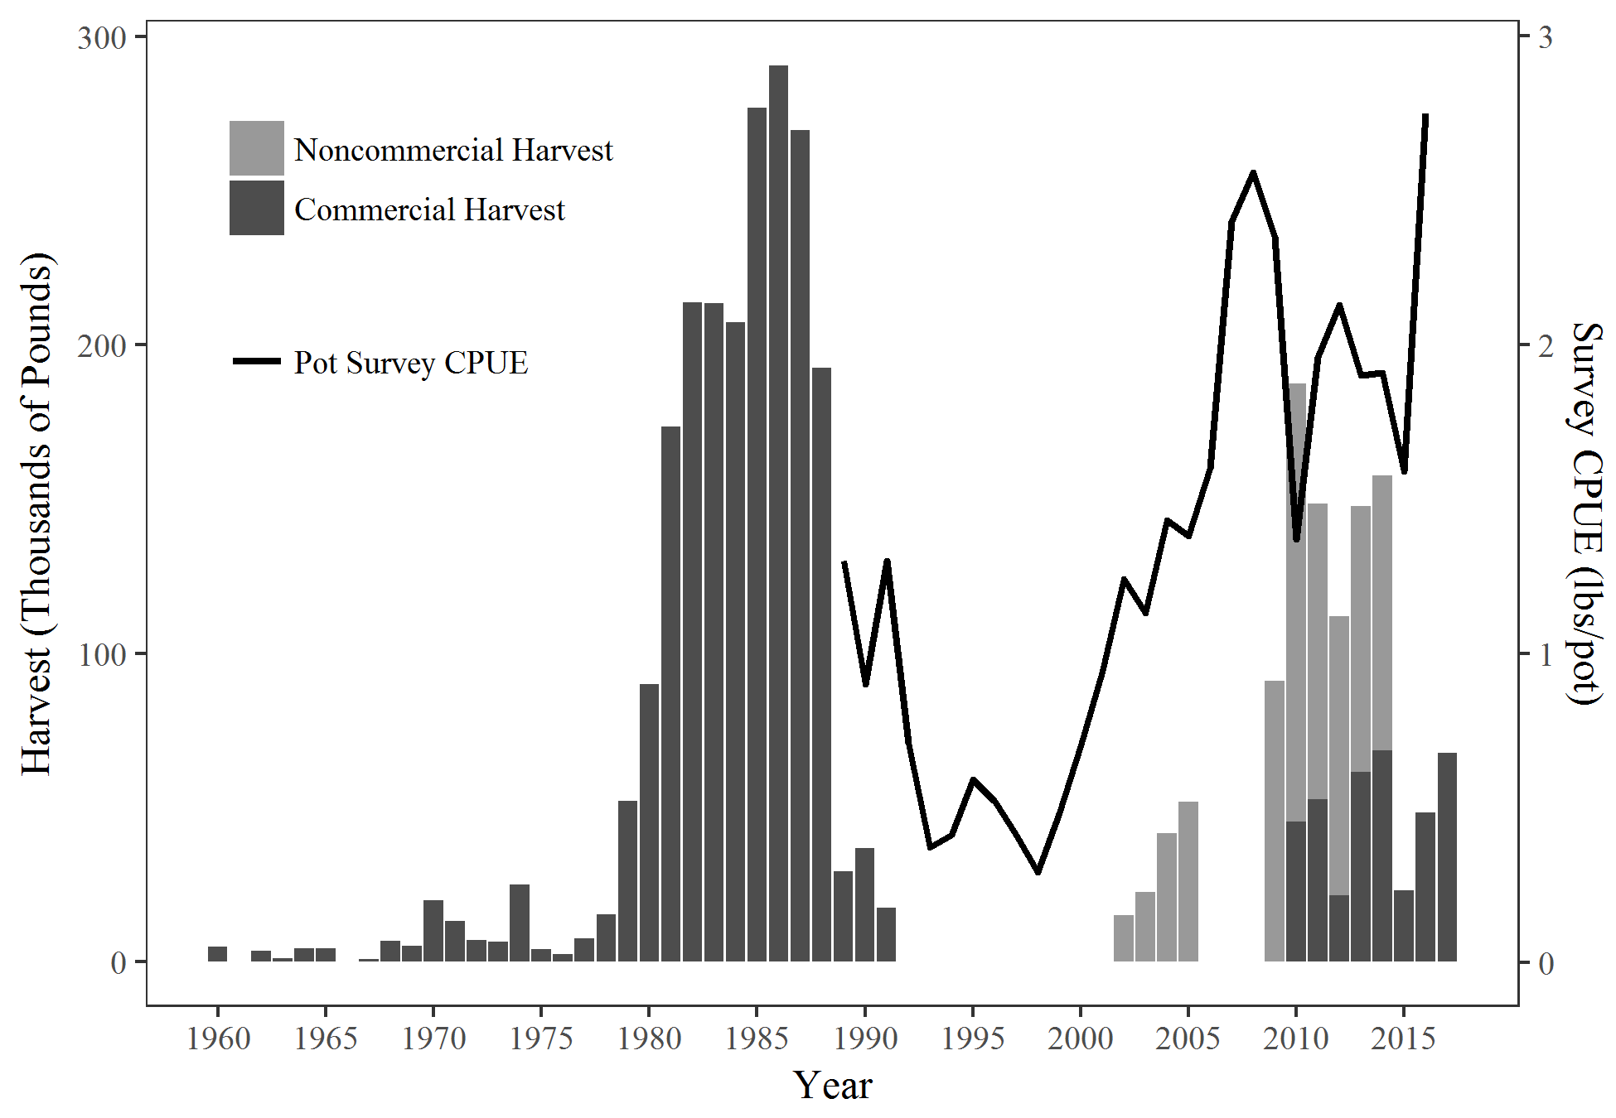

Figure .–Pot shrimp harvest and pot survey CPUE of Spot Shrimp in Prince William Sound. Noncommercial harvest is unavailable prior to 2002 or for 2006–2008. The commercial fishery was closed from 1992–2009. Survey CPUE includes all sizes. Noncommercial harvest is unavailable for the years prior to 2002 and for 2006–2008 because harvest permits were not required.

Add 2015­-2017 NC harvest when available.

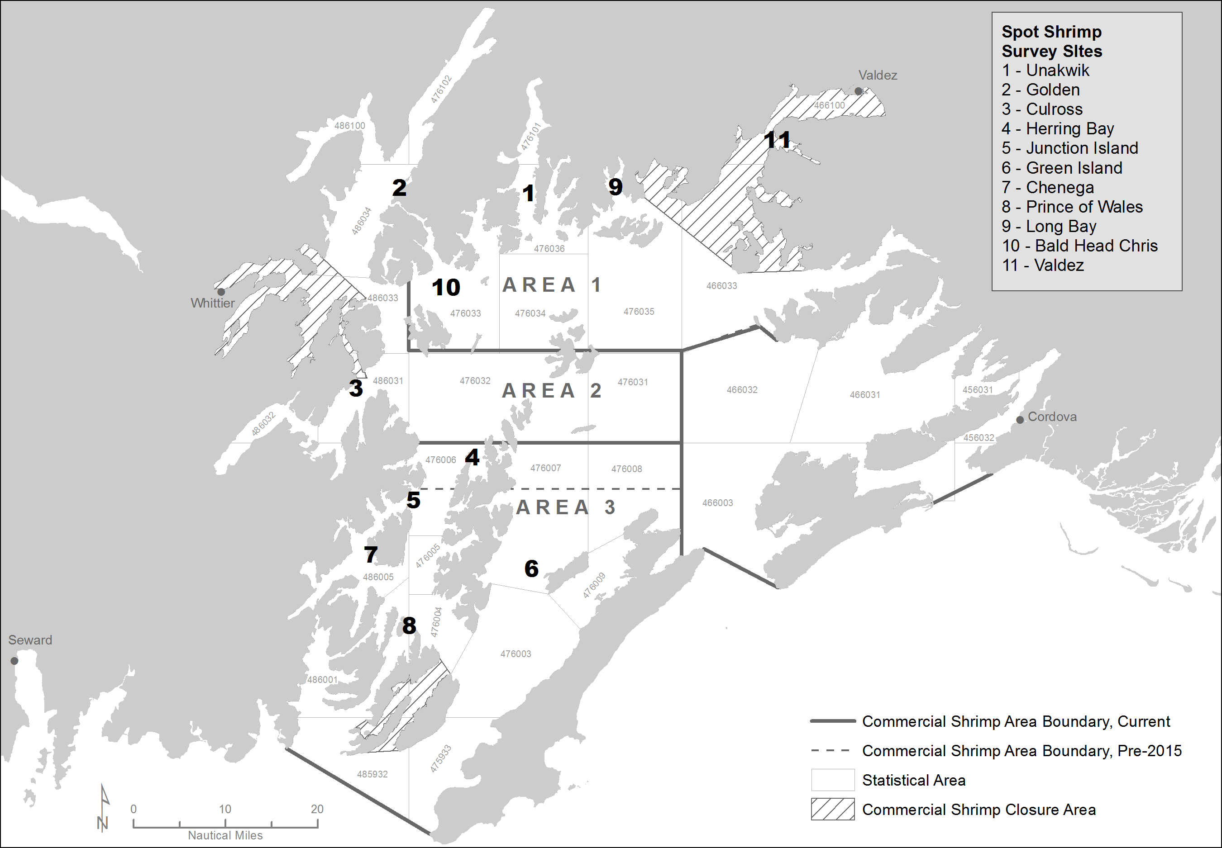

Figure .–PWS spot shrimp pot survey sites and management areas.

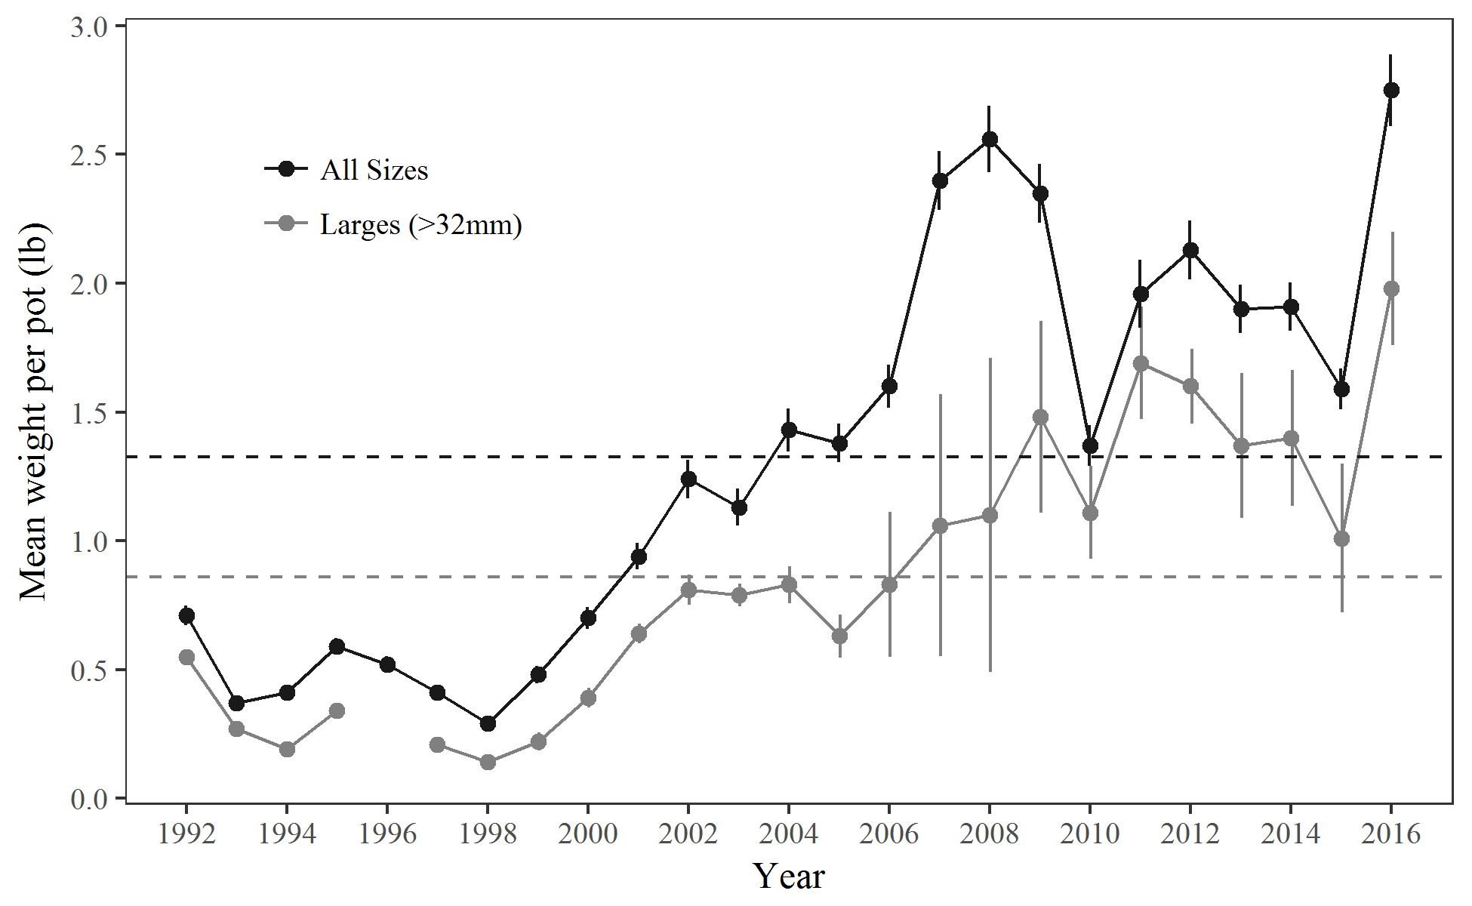

Figure .–Survey-wide CPUE of spot shrimp in the PWS pot survey. Baselines are 1992–2016 averages and error bars are ±1 SE.

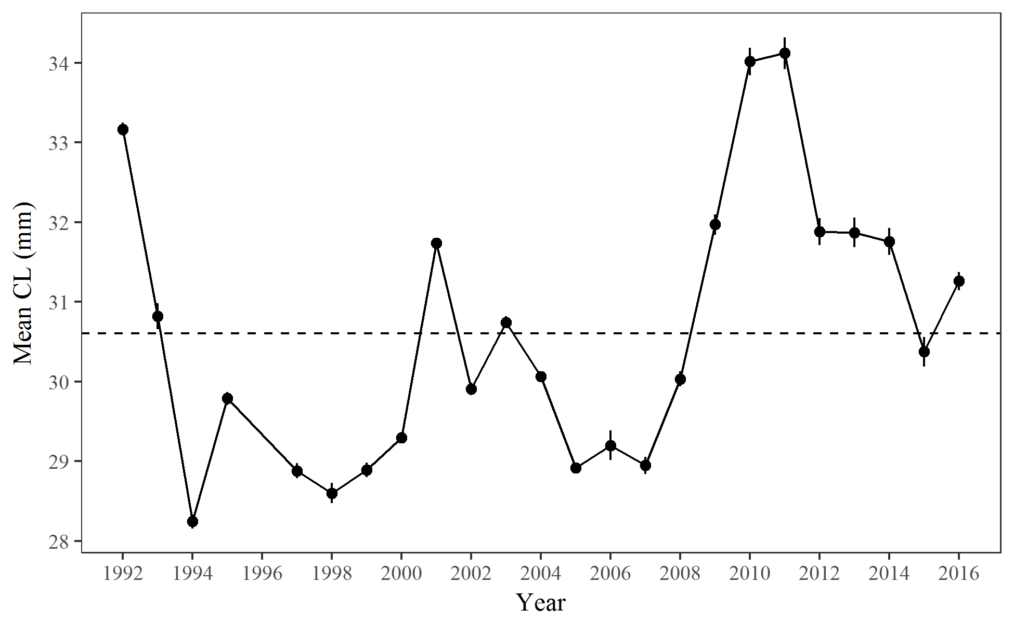

Figure .–Survey-wide mean carapace length ±1 SE of spot shrimp in the PWS pot survey with 1992-2016 average.

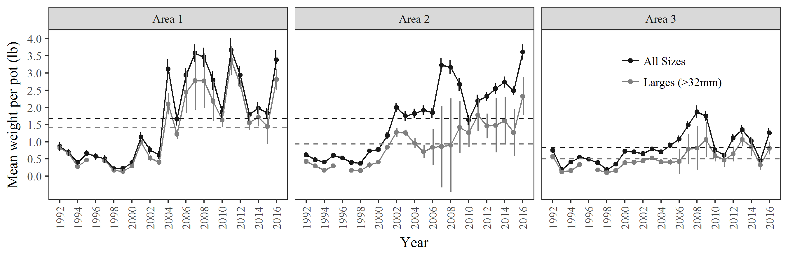

Figure .–CPUE of spot shrimp by management area in the PWS pot survey. Baselines are 1992­–2016 averages and error bars are ±1 SE.

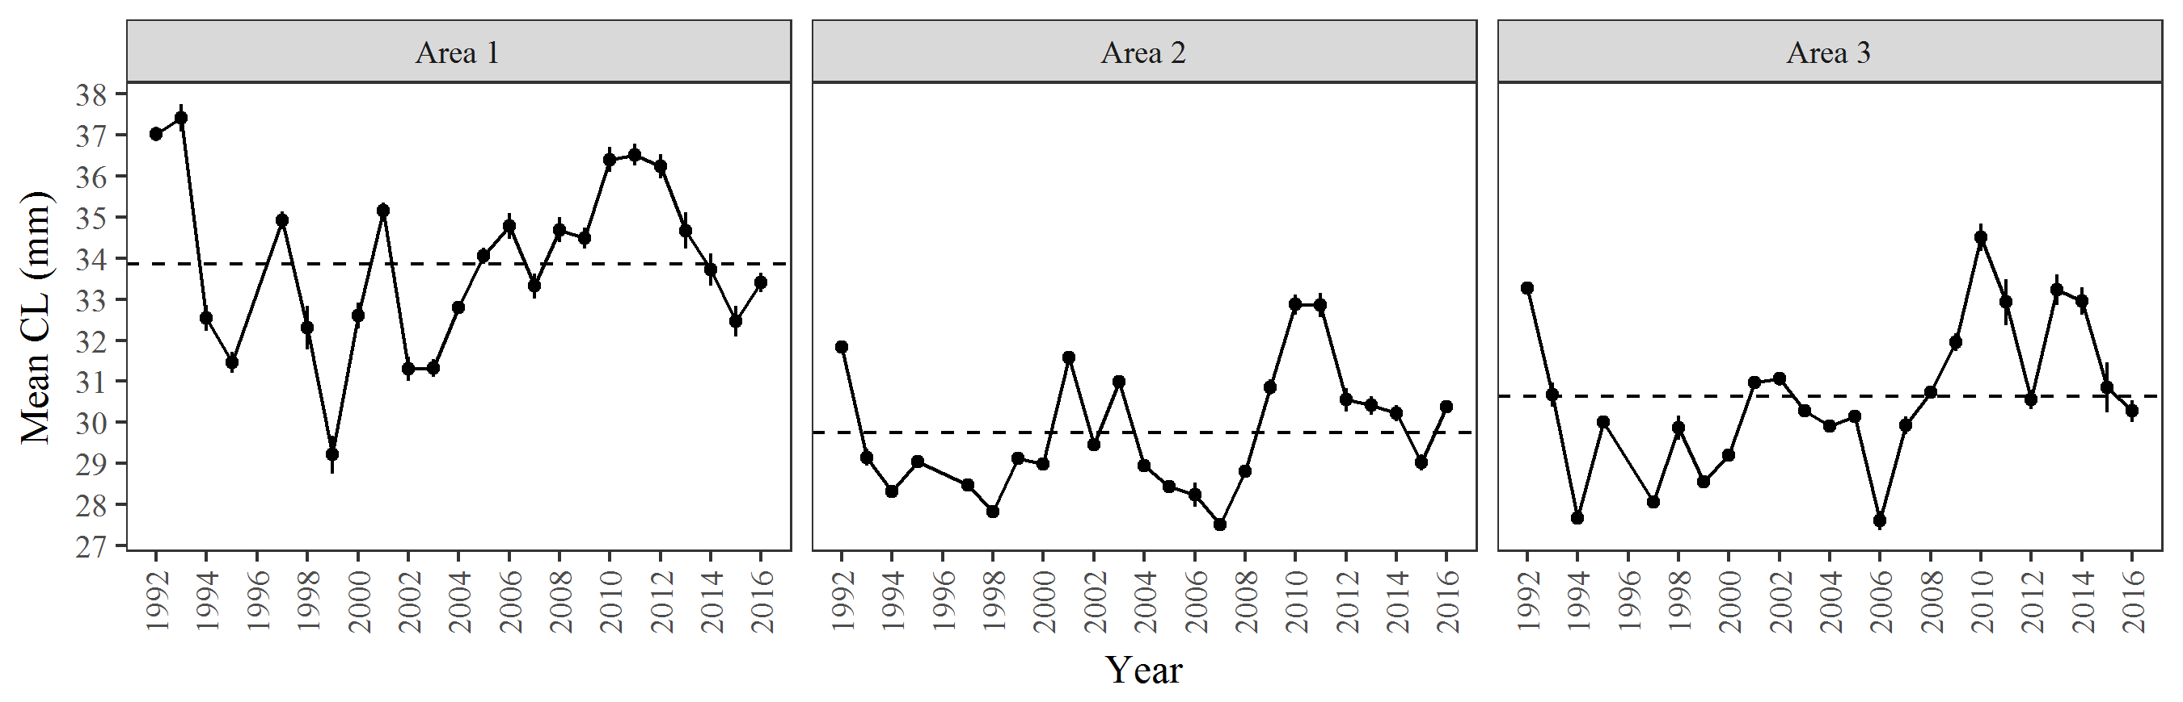

Figure .–Mean carapace length of spot shrimp ±1 SE by management area in the PWS pot survey. Baselines are 1992­–2016 averages.

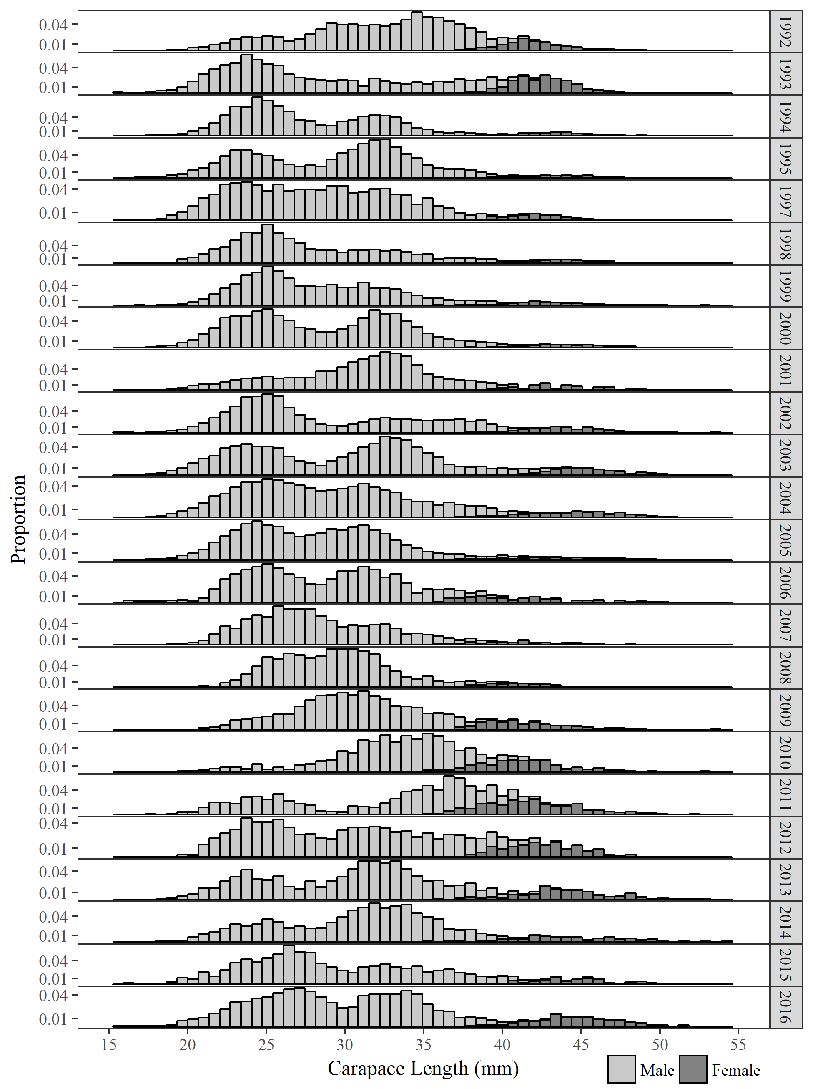

Figure .–Length frequencies of spot shrimp in the PWS spot pot survey.

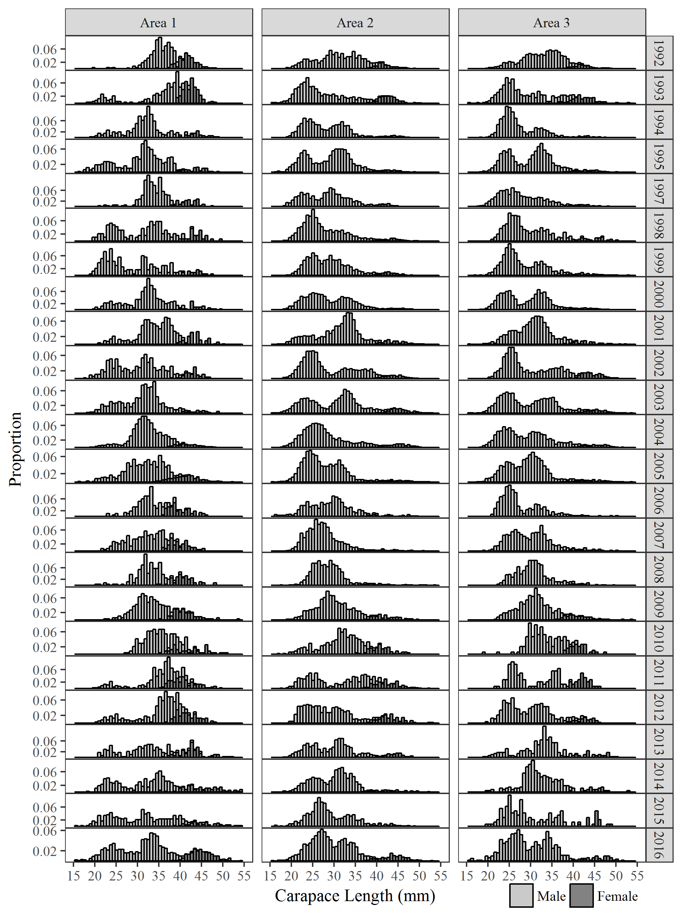

Figure .–Length frequencies of spot shrimp by management area in the PWS pot survey.

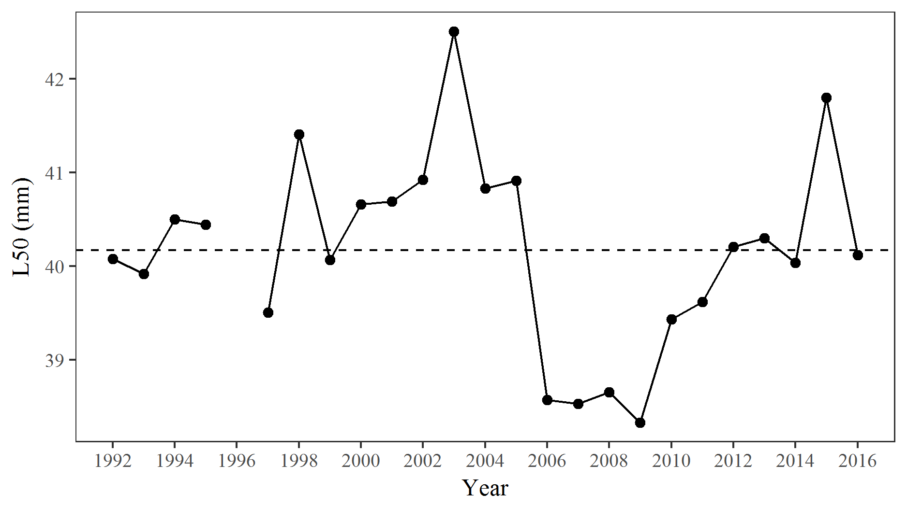

Figure .–Length at 50% female of spot shrimp in the PWS pot survey with 1992­–2016 average.

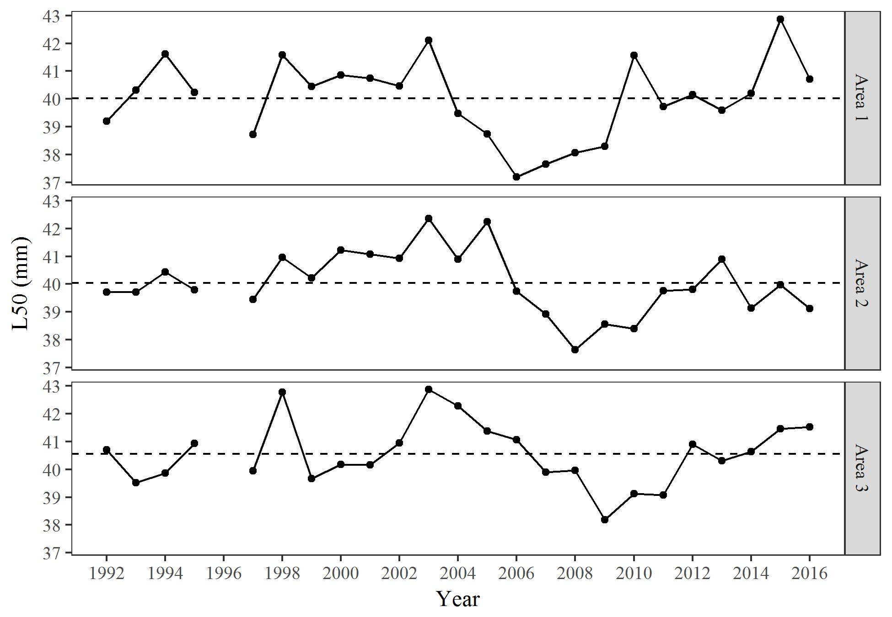

Figure .–Length at 50% female by management area of spot shrimp in the PWS pot survey with 1992­–2016 averages.

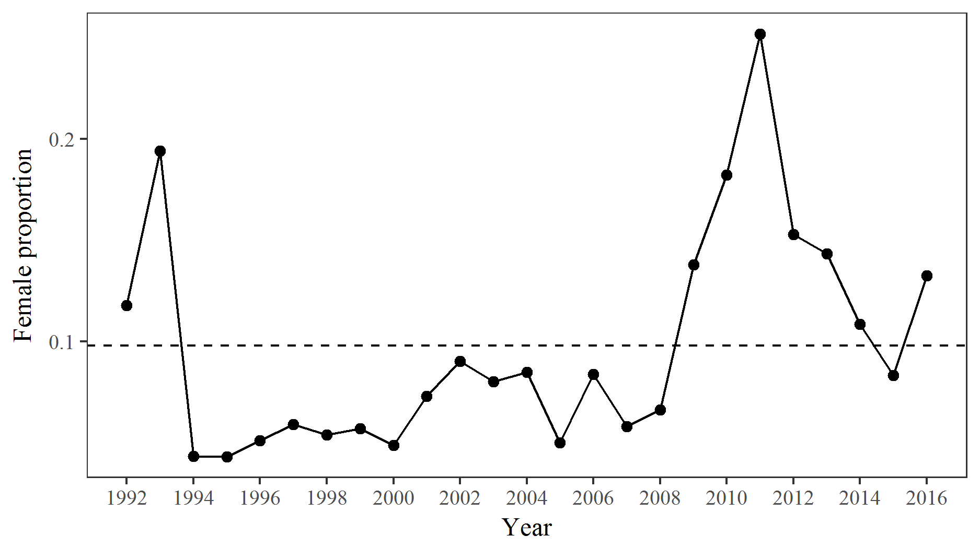

Figure .–Proportion female in the spot shrimp catch of the PWS pot survey with 1992­–2016 average.

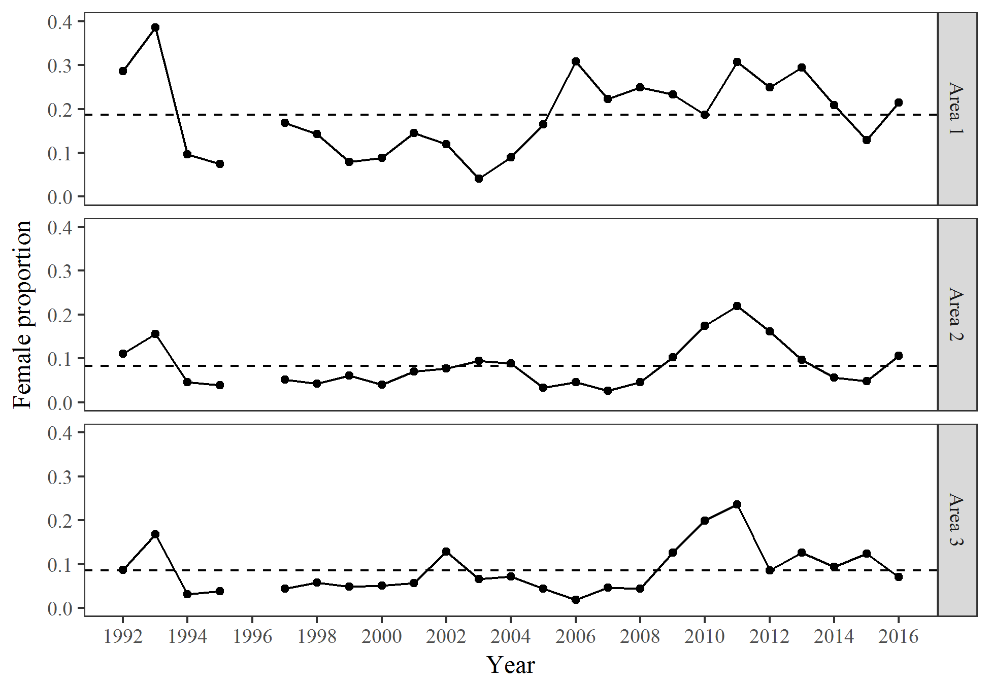

Figure .–Proportion female in the spot shrimp catch of the PWS pot survey by management areas with 1992­–2016 averages.

# APPENDIX A: Stations

Appendix A.– Location and depth of stations used in the Prince William Sound pot survey.

|  |  |  |  |  |  |  |
| --- | --- | --- | --- | --- | --- | --- |
| Site ID | Site Name | Station | Latitude | Longitude | Min Depth (m) | Max Depth (m) |
| 1 | Unakwik | A | 60.995988 | -147.543121 | 82.0 | 127.5 |
| 1 | Unakwik | B | 60.992602 | -147.547878 | 46.0 | 111.8 |
| 1 | Unakwik | C | 60.913596 | -147.550973 | 54.1 | 120.7 |
| 1 | Unakwik | D | 60.909139 | -147.552009 | 56.7 | 169.6 |
| 1 | Unakwik | W | 60.979800 | -147.608533 | 67.7 | 137.2 |
| 1 | Unakwik | X | 60.896250 | -147.532033 | 53.0 | 151.8 |
| 1 | Unakwik | Y | 60.878760 | -147.560016 | 84.1 | 94.4 |
| 1 | Unakwik | Z | 60.879016 | -147.545683 | 109.7 | 160.9 |
| 2 | Golden | A | 60.963007 | -148.027535 | 54.1 | 129.6 |
| 2 | Golden | B | 60.961113 | -148.030769 | 61.4 | 134.5 |
| 2 | Golden | C | 60.958980 | -148.034300 | 56.4 | 133.2 |
| 2 | Golden | D | 60.956817 | -148.037829 | 71.8 | 162.0 |
| 2 | Golden | W | 60.995500 | -148.087600 | 67.7 | 142.6 |
| 2 | Golden | X | 60.999716 | -148.071683 | 67.7 | 146.3 |
| 2 | Golden | Y | 60.991630 | -148.063933 | 75.0 | 142.6 |
| 2 | Golden | Z | 60.955283 | -148.040283 | 62.2 | 111.6 |
| 3 | Culross | A | 60.600683 | -148.197250 | 59.3 | 163.0 |
| 3 | Culross | B | 60.600760 | -148.191983 | 76.3 | 156.0 |
| 3 | Culross | C | 60.601360 | -148.188516 | 53.8 | 127.0 |
| 3 | Culross | D | 60.602783 | -148.184916 | 72.9 | 140.6 |
| 3 | Culross | W | 60.617550 | -148.145116 | 75.0 | 150.0 |
| 3 | Culross | X | 60.611960 | -148.154316 | 73.2 | 137.2 |
| 3 | Culross | Y | 60.609860 | -148.159233 | 73.2 | 182.9 |
| 3 | Culross | Z | 60.607883 | -148.174733 | 73.2 | 118.9 |
| 4 | Herring Bay | A | 60.479816 | -147.767183 | 60.9 | 151.8 |
| 4 | Herring Bay | B | 60.477854 | -147.766588 | 77.6 | 164.3 |
| 4 | Herring Bay | C | 60.476727 | -147.766149 | 75.0 | 127.0 |
| 4 | Herring Bay | D | 60.472250 | -147.766959 | 92.7 | 129.1 |
| 4 | Herring Bay | W | 60.481700 | -147.734733 | 67.7 | 192.0 |
| 4 | Herring Bay | X | 60.476283 | -147.735483 | 67.7 | 124.4 |
| 4 | Herring Bay | Y | 60.465400 | -147.749800 | 71.3 | 109.7 |
| 4 | Herring Bay | Z | 60.466816 | -147.765050 | 69.5 | 133.5 |
| 5 | Junction Island | A | 60.410991 | -147.970801 | 53.3 | 122.0 |
| 5 | Junction Island | B | 60.410450 | -147.967416 | 60.4 | 103.5 |
| 5 | Junction Island | C | 60.382630 | -147.988683 | 52.8 | 106.9 |
| 5 | Junction Island | D | 60.381016 | -147.988950 | 48.6 | 94.3 |
| 5 | Junction Island | W | 60.395730 | -148.004833 | 71.3 | 128.0 |
| 5 | Junction Island | X | 60.406000 | -147.993450 | 71.3 | 129.8 |
| 5 | Junction Island | Y | 60.401183 | -147.979333 | 78.6 | 164.6 |
| 5 | Junction Island | Z | 60.392050 | -147.985416 | 69.5 | 118.9 |
| 6 | Green Is/Montague | A | 60.275198 | -147.541715 | 78.7 | 99.4 |
| 6 | Green Is/Montague | B | 60.274612 | -147.545563 | 71.7 | 124.5 |
| 6 | Green Is/Montague | C | 60.273787 | -147.548602 | 59.0 | 116.9 |
| 6 | Green Is/Montague | D | 60.271698 | -147.552327 | 70.1 | 116.9 |
| 7 | Chenega | A | 60.291297 | -148.149445 | 71.8 | 174.0 |
| 7 | Chenega | B | 60.289557 | -148.145753 | 68.2 | 161.5 |
| 7 | Chenega | C | 60.277324 | -148.130391 | 60.1 | 140.8 |
| 7 | Chenega | D | 60.275277 | -148.124667 | 52.0 | 129.1 |
| 7 | Chenega | W | 60.279000 | -148.194866 | 76.8 | 151.8 |
| 7 | Chenega | X | 60.274183 | -148.188216 | 71.3 | 164.6 |
| 7 | Chenega | Y | 60.265830 | -148.185016 | 78.6 | 179.2 |
| 7 | Chenega | Z | 60.262750 | -148.194833 | 62.2 | 128.0 |
| 8 | Prince of Wales | A | 60.184017 | -148.029788 | 65.3 | 137.2 |
| 8 | Prince of Wales | B | 60.183417 | -148.003857 | 58.3 | 181.3 |
| 8 | Prince of Wales | C | 60.139142 | -147.989381 | 53.0 | 101.4 |
| 8 | Prince of Wales | D | 60.131849 | -148.002365 | 58.8 | 145.0 |
| 8 | Prince of Wales | W | 60.178560 | -148.042683 | 69.5 | 140.8 |
| 8 | Prince of Wales | X | 60.201460 | -148.038083 | 65.8 | 170.1 |
| 8 | Prince of Wales | Y | 60.190950 | -148.012683 | 73.2 | 201.2 |
| 8 | Prince of Wales | Z | 60.175516 | -147.995766 | 56.7 | 137.2 |
| 9 | Long Bay | A | 60.962016 | -147.245499 | 67.9 | 132.2 |
| 9 | Long Bay | B | 60.958499 | -147.246833 | 88.8 | 144.2 |
| 9 | Long Bay | C | 60.965666 | -147.230466 | 65.8 | 135.3 |
| 9 | Long Bay | D | 60.962283 | -147.231083 | 66.6 | 146.8 |
| 9 | Long Bay | W | 60.972900 | -147.242183 | 82.3 | 142.6 |
| 9 | Long Bay | X | 60.945100 | -147.234616 | 84.1 | 113.9 |
| 9 | Long Bay | Y | 60.930400 | -147.227550 | 82.3 | 160.9 |
| 9 | Long Bay | Z | 60.931816 | -147.243616 | 76.8 | 100.6 |
| 10 | Bald Head Chris | A | 60.793566 | -147.863333 | 69.1 | 127.3 |
| 10 | Bald Head Chris | B | 60.788449 | -147.836266 | 51.2 | 118.9 |
| 10 | Bald Head Chris | C | 60.788216 | -147.866116 | 122.2 | 148.9 |
| 10 | Bald Head Chris | D | 60.785716 | -147.859999 | 60.4 | 113.8 |
| 10 | Bald Head Chris | W | 60.791060 | -147.817800 | 75.0 | 139.0 |
| 10 | Bald Head Chris | X | 60.783030 | -147.800383 | 73.2 | 115.2 |
| 10 | Bald Head Chris | Y | 60.780300 | -147.842933 | 78.6 | 151.8 |
| 10 | Bald Head Chris | Z | 60.806460 | -147.859233 | 69.5 | 148.1 |
| 11 | Valdez | A | 61.046433 | -146.646600 | 73.8 | 149.4 |
| 11 | Valdez | B | 61.044699 | -146.642499 | 52.4 | 184.1 |
| 11 | Valdez | C | 61.085349 | -146.670766 | 57.9 | 152.4 |
| 11 | Valdez | D | 61.087983 | -146.669316 | 64.0 | 183.5 |

# APPENDIX B: CPUE by Statisitcal Area

Appendix A.–CPUE (lb/pot) of spot shrimp in the Prince William Sound pot survey and commercial pot fishery by statistical area, 1992 to 2016. All sizes of shrimp are included. Only statistical areas containing survey sites are included.

|  |  |  |  |  |  |  |  |  |  |  |  |  |  |  |  |  |  |  |  |  |  |  |  |  |  |  |  |  |
| --- | --- | --- | --- | --- | --- | --- | --- | --- | --- | --- | --- | --- | --- | --- | --- | --- | --- | --- | --- | --- | --- | --- | --- | --- | --- | --- | --- | --- |
|  | 466100 |  | 476006 | |  | 476007 | |  | 476033 | |  | 476035 | |  | 476036 | |  | 486001 | |  | 486005 | |  | 486031 | |  | 486034 | |
| Year | Survey |  | Survey | Fishery |  | Survey | Fishery |  | Survey | Fishery |  | Survey | Fishery |  | Survey | Fishery |  | Survey | Fishery |  | Survey | Fishery |  | Survey | Fishery |  | Survey | Fishery |
| 1992 | nd |  | 0.84 | nd |  | 0.63 | nd |  | nd | nd |  | nd | nd |  | 0.86 | nd |  | 0.53 | nd |  | 0.87 | nd |  | 0.56 | nd |  | 0.57 | nd |
| 1993 | nd |  | 0.27 | nd |  | 0.12 | nd |  | nd | nd |  | nd | nd |  | 0.69 | nd |  | 0.21 | nd |  | 0.21 | nd |  | 0.47 | nd |  | 0.63 | nd |
| 1994 | nd |  | 0.36 | nd |  | 0.18 | nd |  | nd | nd |  | nd | nd |  | 0.40 | nd |  | 0.70 | nd |  | 0.48 | nd |  | 0.24 | nd |  | 0.53 | nd |
| 1995 | nd |  | 0.44 | nd |  | 0.26 | nd |  | nd | nd |  | nd | nd |  | 0.67 | nd |  | 1.01 | nd |  | 0.69 | nd |  | 0.76 | nd |  | 0.44 | nd |
| 1996 | nd |  | 0.47 | nd |  | 0.68 | nd |  | nd | nd |  | nd | nd |  | 0.58 | nd |  | 0.73 | nd |  | 0.23 | nd |  | 0.66 | nd |  | 0.34 | nd |
| 1997 | nd |  | 0.47 | nd |  | 0.48 | nd |  | nd | nd |  | nd | nd |  | 0.50 | nd |  | 0.55 | nd |  | 0.21 | nd |  | 0.39 | nd |  | 0.24 | nd |
| 1998 | nd |  | 0.38 | nd |  | nd | nd |  | nd | nd |  | nd | nd |  | 0.22 | nd |  | nd | nd |  | 0.26 | nd |  | 0.37 | nd |  | 0.14 | nd |
| 1999 | nd |  | 0.48 | nd |  | 0.27 | nd |  | nd | nd |  | nd | nd |  | 0.22 | nd |  | 0.22 | nd |  | 0.62 | nd |  | 0.90 | nd |  | 0.58 | nd |
| 2000 | nd |  | 0.53 | nd |  | 0.65 | nd |  | nd | nd |  | nd | nd |  | 0.40 | nd |  | 0.54 | nd |  | 1.29 | nd |  | 0.78 | nd |  | 0.92 | nd |
| 2001 | nd |  | 0.53 | nd |  | 0.93 | nd |  | nd | nd |  | nd | nd |  | 1.14 | nd |  | 0.69 | nd |  | 0.75 | nd |  | 1.00 | nd |  | 1.96 | nd |
| 2002 | nd |  | 1.05 | nd |  | nd | nd |  | nd | nd |  | nd | nd |  | 0.77 | nd |  | 0.46 | nd |  | 0.91 | nd |  | 1.47 | nd |  | 2.94 | nd |
| 2003 | nd |  | 0.70 | nd |  | 1.01 | nd |  | nd | nd |  | nd | nd |  | 0.61 | nd |  | 0.51 | nd |  | 1.31 | nd |  | 1.23 | nd |  | 2.97 | nd |
| 2004 | nd |  | 0.96 | nd |  | 0.60 | nd |  | nd | nd |  | nd | nd |  | 3.12 | nd |  | 0.48 | nd |  | 1.45 | nd |  | 0.57 | nd |  | 3.27 | nd |
| 2005 | nd |  | 0.88 | nd |  | 0.78 | nd |  | nd | nd |  | nd | nd |  | 1.66 | nd |  | 0.33 | nd |  | 1.91 | nd |  | 1.06 | nd |  | 3.47 | nd |
| 2006 | nd |  | 0.82 | nd |  | 0.44 | nd |  | nd | nd |  | nd | nd |  | 2.93 | nd |  | 0.82 | nd |  | 2.21 | nd |  | 1.30 | nd |  | 3.40 | nd |
| 2007 | nd |  | 1.68 | nd |  | 0.45 | nd |  | nd | nd |  | nd | nd |  | 3.58 | nd |  | 1.46 | nd |  | 2.67 | nd |  | 1.83 | nd |  | 5.92 | nd |
| 2008 | nd |  | 1.83 | nd |  | 0.46 | nd |  | nd | nd |  | nd | nd |  | 3.46 | nd |  | 1.70 | nd |  | 4.15 | nd |  | 1.66 | nd |  | 5.28 | nd |
| 2009 | nd |  | 1.18 | nd |  | nd | nd |  | nd | nd |  | 0.62 | nd |  | 4.90 | nd |  | 1.26 | nd |  | 3.17 | nd |  | 1.74 | nd |  | 4.70 | nd |
| 2010 | nd |  | 0.53 | nd |  | nd | nd |  | nd | 2.01 |  | 0.87 | 3.99 |  | 2.88 | 2.64 |  | 0.41 | nd |  | 1.66 | nd |  | 1.20 | nd |  | 2.84 | nd |
| 2011 | nd |  | 0.55 | 0.51 |  | nd | 0.54 |  | nd | nd |  | 1.07 | nd |  | 6.34 | nd |  | 0.26 | nd |  | 1.48 | nd |  | 1.24 | 1.36 |  | 4.27 | 1.86 |
| 2012 | nd |  | 1.47 | 0.85 |  | nd | 0.06 |  | 1.54 | nd |  | 0.54 | nd |  | 6.74 | nd |  | 0.89 | 0.98 |  | 1.47 | 0.88 |  | 1.77 | nd |  | 3.19 | nd |
| 2013 | 2.43 |  | 1.13 | nd |  | nd | nd |  | 0.79 | 1.15 |  | 0.33 | 1.34 |  | 4.29 | 2.34 |  | 1.44 | nd |  | 1.79 | nd |  | 1.94 | nd |  | 4.31 | nd |
| 2014 | 2.07 |  | 1.04 | nd |  | nd | nd |  | 1.33 | 1.63 |  | 0.43 | nd |  | 4.16 | nd |  | 0.72 | nd |  | 1.89 | nd |  | 2.47 | 1.45 |  | 4.14 | 1.46 |
| 2015 | 2.33 |  | 1.44 | 1.09 |  | nd | nd |  | 2.13 | nd |  | 0.55 | nd |  | 2.83 | nd |  | 0.37 | 1.24 |  | 0.63 | 1.02 |  | 1.80 | nd |  | 3.14 | nd |
| 2016 | nd |  | 1.56 | nd |  | nd | nd |  | 3.24 | 1.39 |  | 0.88 | 1.46 |  | 6.01 | 2.04 |  | 1.11 | nd |  | 1.46 | nd |  | 3.73 | nd |  | 5.19 | nd |

# APPENDIX C: Ovigerity by statitistical Area

Appendix A.–Percent of female spot shrimp with eggs in the Prince William Sound pot survey by statistical area, 1992 to 2016. The survey-wide values do not include the Valdez site which is outside the commercial fishing area.

|  |  |  |  |  |  |  |  |  |  |  |  |
| --- | --- | --- | --- | --- | --- | --- | --- | --- | --- | --- | --- |
| Year | 466100 | 476006 | 476007 | 476033 | 476035 | 476036 | 486001 | 486005 | 486031 | 486034 | Survey-wide |
| 1992 | nd | 97.1 | 96.3 | nd | nd | 93.4 | 100.0 | 99.0 | 100.0 | 97.5 | 96.8 |
| 1993 | nd | 100.0 | 87.5 | nd | nd | 96.6 | 100.0 | 91.4 | 97.0 | 100.0 | 97.7 |
| 1994 | nd | 85.2 | 85.7 | nd | nd | 100.0 | 93.2 | 100.0 | 100.0 | 100.0 | 95.5 |
| 1995 | nd | – | – | nd | nd | – | – | – | – | – | – |
| 1996 | nd | – | – | nd | nd | – | – | – | – | – | – |
| 1997 | nd | – | – | nd | nd | – | – | – | – | – | – |
| 1998 | nd | 100.0 | nd | nd | nd | 100.0 | nd | 100.0 | 100.0 | 95.7 | 99.2 |
| 1999 | nd | 97.1 | 100.0 | nd | nd | 100.0 | 100.0 | 100.0 | 97.1 | 94.4 | 97.8 |
| 2000 | nd | 94.6 | 93.5 | nd | nd | 100.0 | 100.0 | 97.0 | 100.0 | 97.5 | 97.2 |
| 2001 | nd | 100.0 | 100.0 | nd | nd | 98.1 | 100.0 | 100.0 | 100.0 | 100.0 | 99.6 |
| 2002 | nd | 96.6 | nd | nd | nd | 95.2 | 98.2 | 100.0 | 97.7 | 100.0 | 98.5 |
| 2003 | nd | 98.6 | 100.0 | nd | nd | 100.0 | 100.0 | 99.2 | 100.0 | 100.0 | 99.7 |
| 2004 | nd | 96.8 | 93.9 | nd | nd | 98.0 | 100.0 | 96.6 | 90.0 | 98.2 | 97.3 |
| 2005 | nd | 96.9 | 91.3 | nd | nd | 92.9 | 100.0 | 95.9 | 94.4 | 98.4 | 95.0 |
| 2006 | nd | 100.0 | 100.0 | nd | nd | 90.9 | 100.0 | 100.0 | 50.0 | 100.0 | 91.7 |
| 2007 | nd | 80.0 | 100.0 | nd | nd | 77.3 | 50.0 | 100.0 | 100.0 | 94.4 | 83.7 |
| 2008 | nd | 77.8 | nd | nd | nd | 78.7 | 100.0 | 87.1 | 100.0 | 80.4 | 81.4 |
| 2009 | nd | 93.1 | nd | nd | 75.0 | 89.3 | 66.7 | 82.1 | 93.3 | 88.9 | 88.0 |
| 2010 | nd | 94.6 | nd | nd | 100.0 | 83.3 | 88.9 | 95.7 | 92.1 | 100.0 | 93.5 |
| 2011 | nd | 100.0 | nd | nd | 100.0 | 98.4 | 100.0 | 100.0 | 95.0 | 100.0 | 99.1 |
| 2012 | nd | 87.5 | nd | 100.0 | 100.0 | 84.5 | 96.2 | 90.5 | 87.5 | 96.1 | 90.8 |
| 2013 | 94.4 | 100.0 | nd | 100.0 | 50.0 | 69.7 | 100.0 | 95.5 | 100.0 | 100.0 | 87.1 |
| 2014 | 88.9 | 100.0 | nd | 77.8 | 88.9 | 98.4 | 33.3 | 80.0 | 100.0 | 100.0 | 93.1 |
| 2015 | 100.0 | 100.0 | nd | 100.0 | 100.0 | 96.8 | 100.0 | 100.0 | 92.9 | 100.0 | 98.3 |
| 2016 | nd | 100.0 | nd | 100.0 | 100.0 | 100.0 | 100.0 | 100.0 | 99.0 | 98.7 | 99.6 |